Project Design Phase-I
Solution Architecture

Date | 19 September 2023
Team ID | NM2023TMID00044
Project Name | Quantitative Analysis of Candidates in 2019 Lok Sabha Elections
Maximum Marks | 4 Marks

Solution Architecture:
Solution architecture is a complex process – with many sub-processes – that bridges the gap between business problems and technology solutions. Its goals are to:
- Find the best tech solution to solve existing business problems.
- Describe the structure, characteristics, behaviour, and other aspects of the software to project stakeholders.
- Define features, development phases, and solution requirements.
- Provide specifications according to which the solution is defined, managed, and delivered.

Example - Solution Architecture Diagram:

Reference: https://www.google.com/url?sa=i&url=https%3A%2F%2Fwww.researchgate.net%2Ffigure%2FArchitecture-of-the-proposed-Big-Data-analytics-integration-solution_fig7_324596564&psig=AOvVaw3u0Uo2YEcUMPrZN0l3Kl0m&ust=1698942778337000&source=images&cd=vfe&opi=89978449&ved=0CBIQjRxqFwoTCKjd85ido4IDFQAAAAAdAAAAABAJ

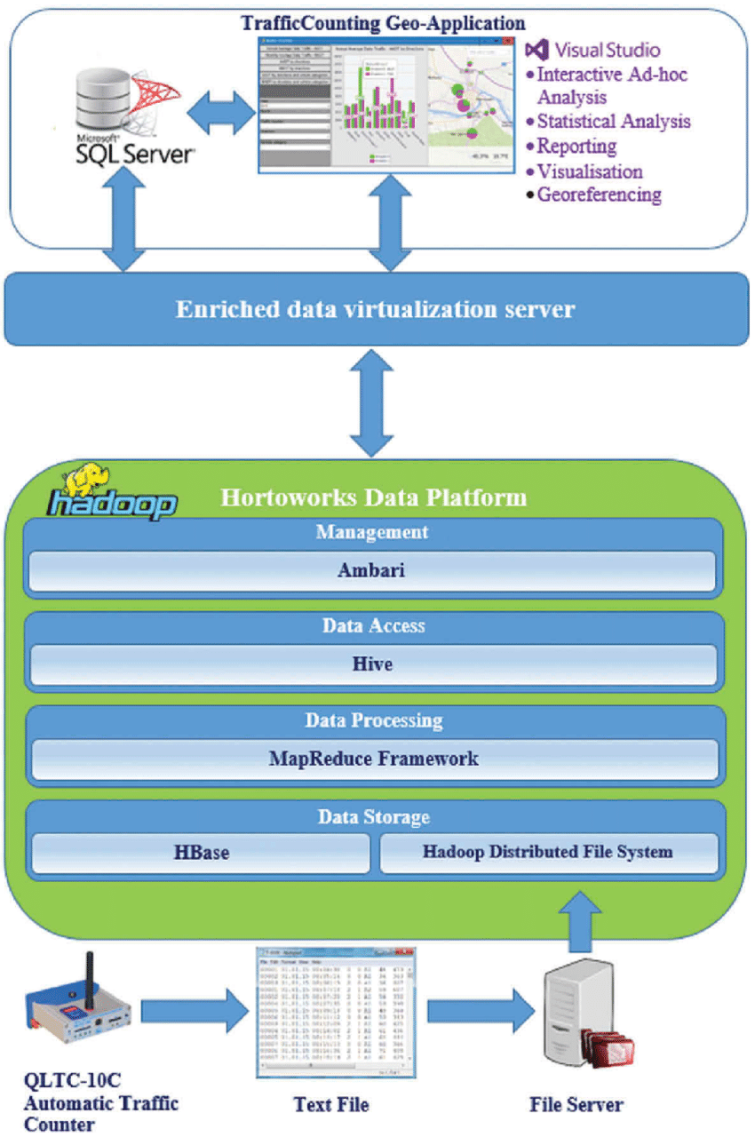

Figure 1: Architecture and data flow

